Reflective Report

On

OnTrend Clothing Website

For

STW205CDE-Developing the Modern Web

Submitted by:

Name: Sayyed Abrar Akhtar

University Id: 10272453

YouTube video Link: <https://youtu.be/PrwTBCroWVE>

Repository Link: <https://github.com/10272453-180072-SayyedAbrarAkhtar/STW205CDE-Developing-the-Modern-Web.git>

Actual word count: 1084

Contents

Introduction 3

Frontend 4

Databases 13

Backends 19

Conclusion 23

References 24

# Introduction

Project begin with designing and developing a full stack online clothing website. I have used HTML, CSS, JavaScript, jQuery for front end designing and development. For backend I have used Django framework as templating language and to store website data, I have used MySQL as database.

The website has two parts, frontend and backend. We need to login to access the backend of the website. From backend, crud operation is performed in data.

Talking about the features, the website has options to add new products, update existing one and delete old one or one we don’t need. Only authorized person can perform above operations. So, we can register as user to access the backend. There are two option for registering as a user either admin user or normal user. Normal user is not allowed to perform delete operation of the website data.

New customers can be manually created by users or the visitors can themselves create their account. This helps us to store customer information. Customer can update and delete their account. Admin can also update and delete customers account. Moreover, products created are displayed on the frontend. Visitors can look over the products and write their review about the products. Such reviews are displayed at the homepage which transform into trust on our products. Contents on the homepage like header, button text, banner images can be customized from the backend. These are some features of website.

The website aims to be user friendly and attractive. It should help backend user to manipulate website data easily. Navigation through add, update and delete options should be simple so that user don’t need to waste time finding out. The website should be able to grab visitor attention. Customizing should be easier. To achieve these objectives, I have included the above features in the website. Navigation through website is simple and attractive

I had made a work plan from beginning to end. Plan initiates with designing paper prototype of the website and transforming it into designing actual project. While coding paperwork into actual work many errors were discovered. Solving those errors were fun and I have learned new skills. From this project I have learned data retrieval and manipulation operations process in websites.

# Frontend

Frontend is the part of website that is designed for the visitors and the customers. Products and its detailed information are displayed in this part of website for the visitors. I have used HTML, CSS, Bootstrap, jQuery, JavaScript, Grid in designing and developing the website. (W3schools.com, 2020)

HTML and CSS are the basic element in the process of building website. Hyper Text Markup language, HTML helps in defining structure and meaning of web content. I have used HTML5 in the structuring of website. CSS is a stylesheet language that helps in defining the presentation and layout of the website. I have applied CSS3 in the website. (W3schools.com, 2020)

I have used JavaScript and jQuery (JavaScript library) in programming the website behavior and managing the various. jQuery is a feature-rich JavaScript library which is fast and simple. For event like click event or document ready state of the webpages, I have used jQuery in performing certain tasks. JavaScript is a just-in-time compiled programming. (W3schools.com, 2020)

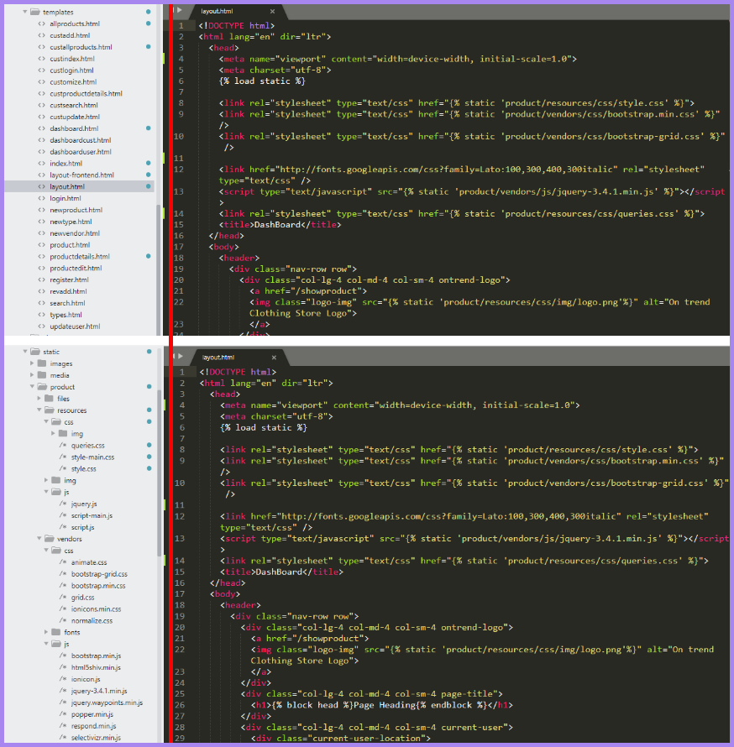

Figure 1: Front-end directories tree

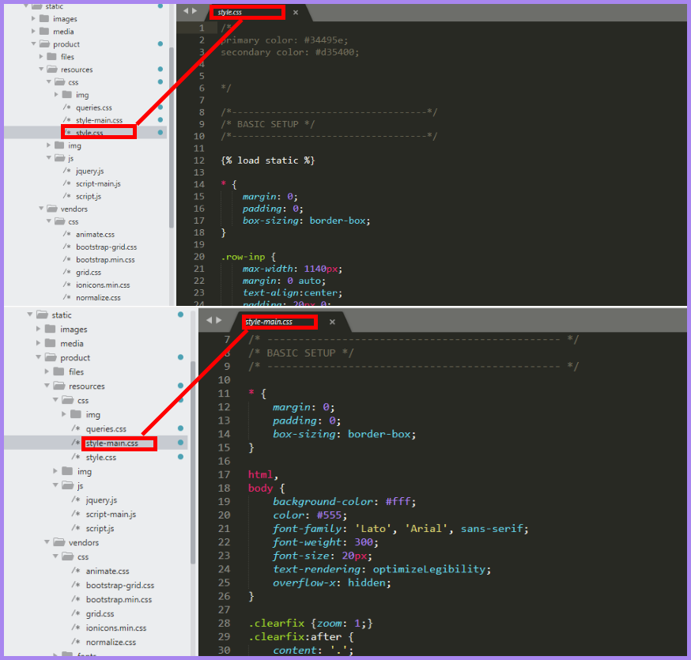

Figure 2: Custom Stylesheets

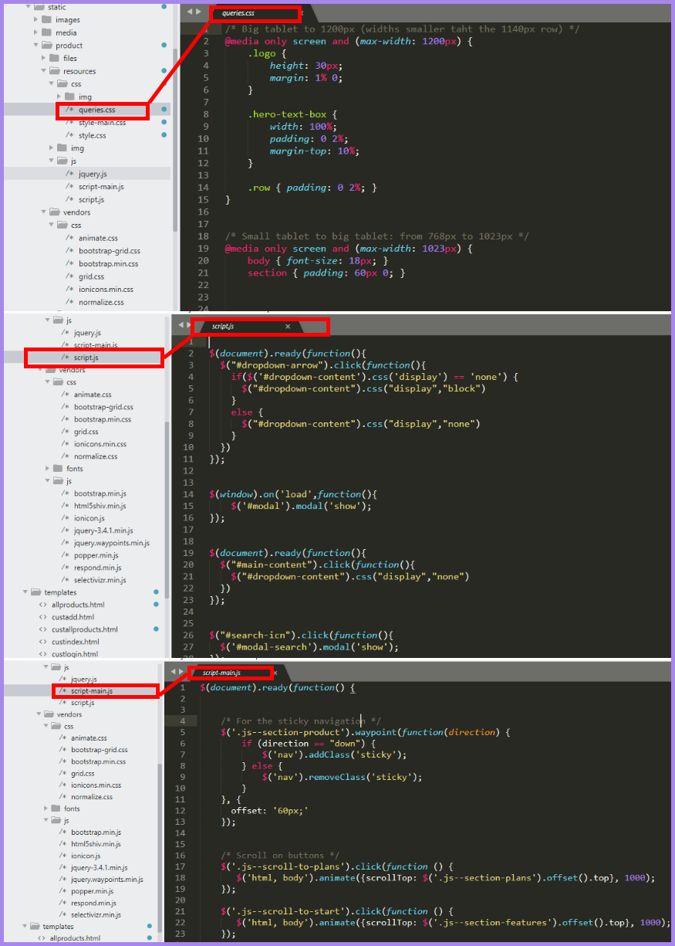

Figure 3: Media queries & JavaScript

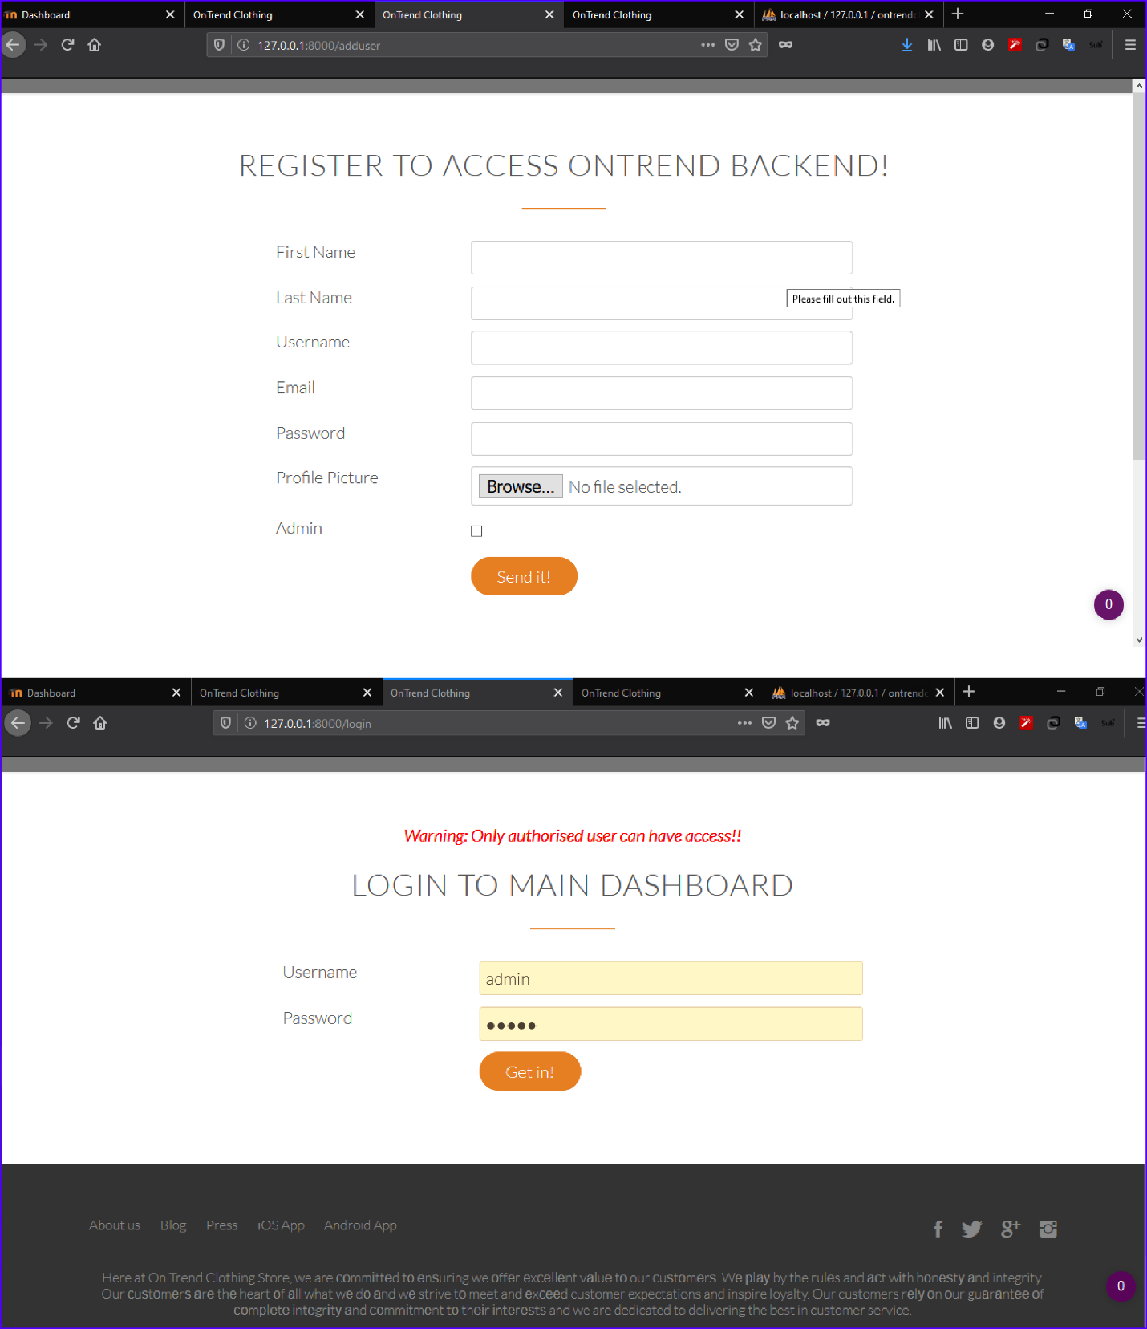

Figure 4: Dashboard access signup and login page

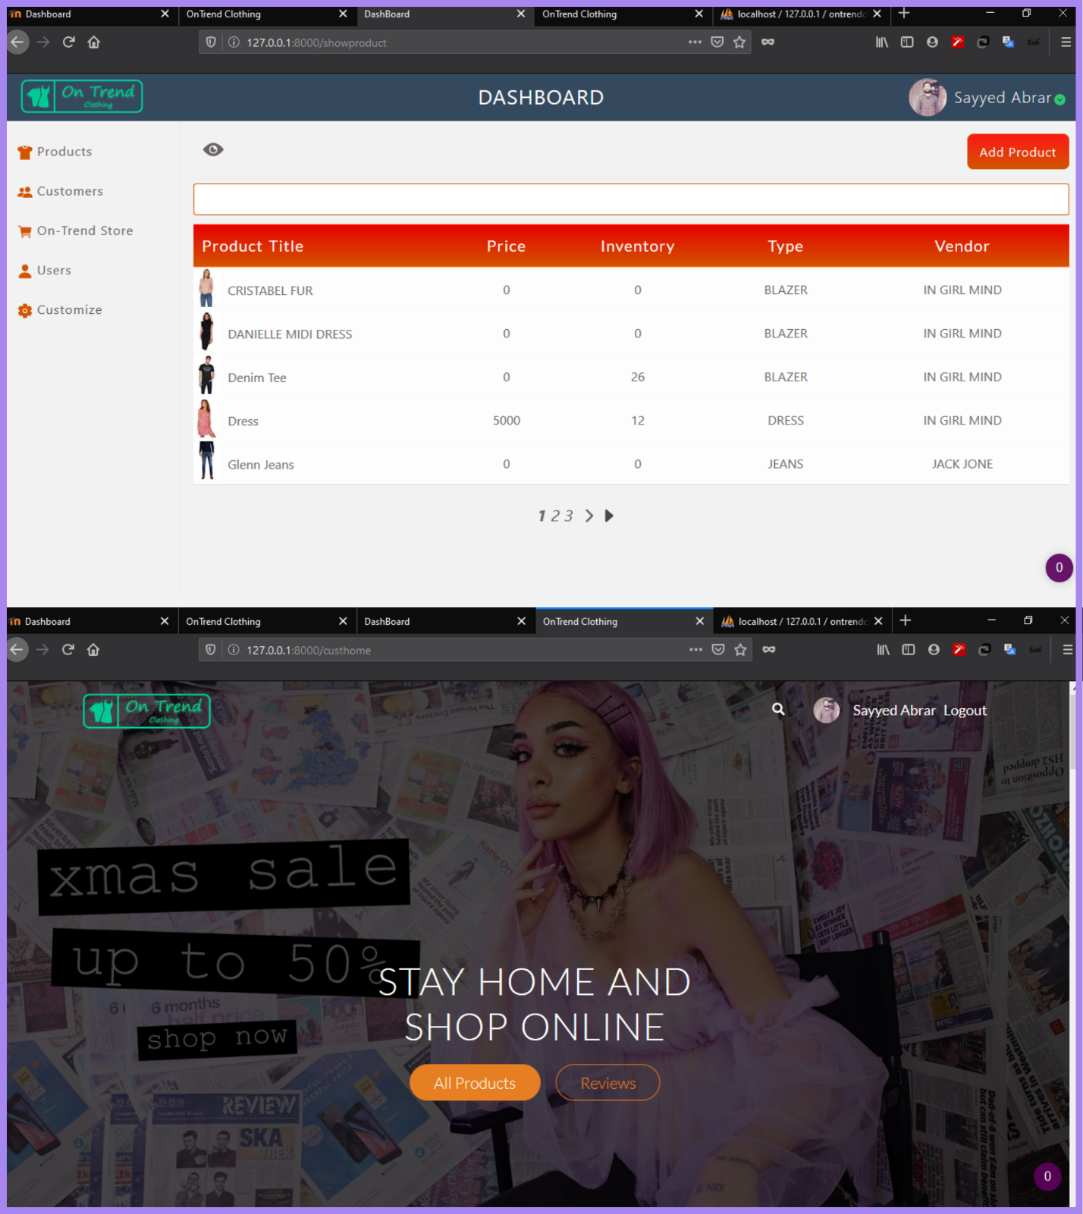

Figure 5: Dashboard and index page

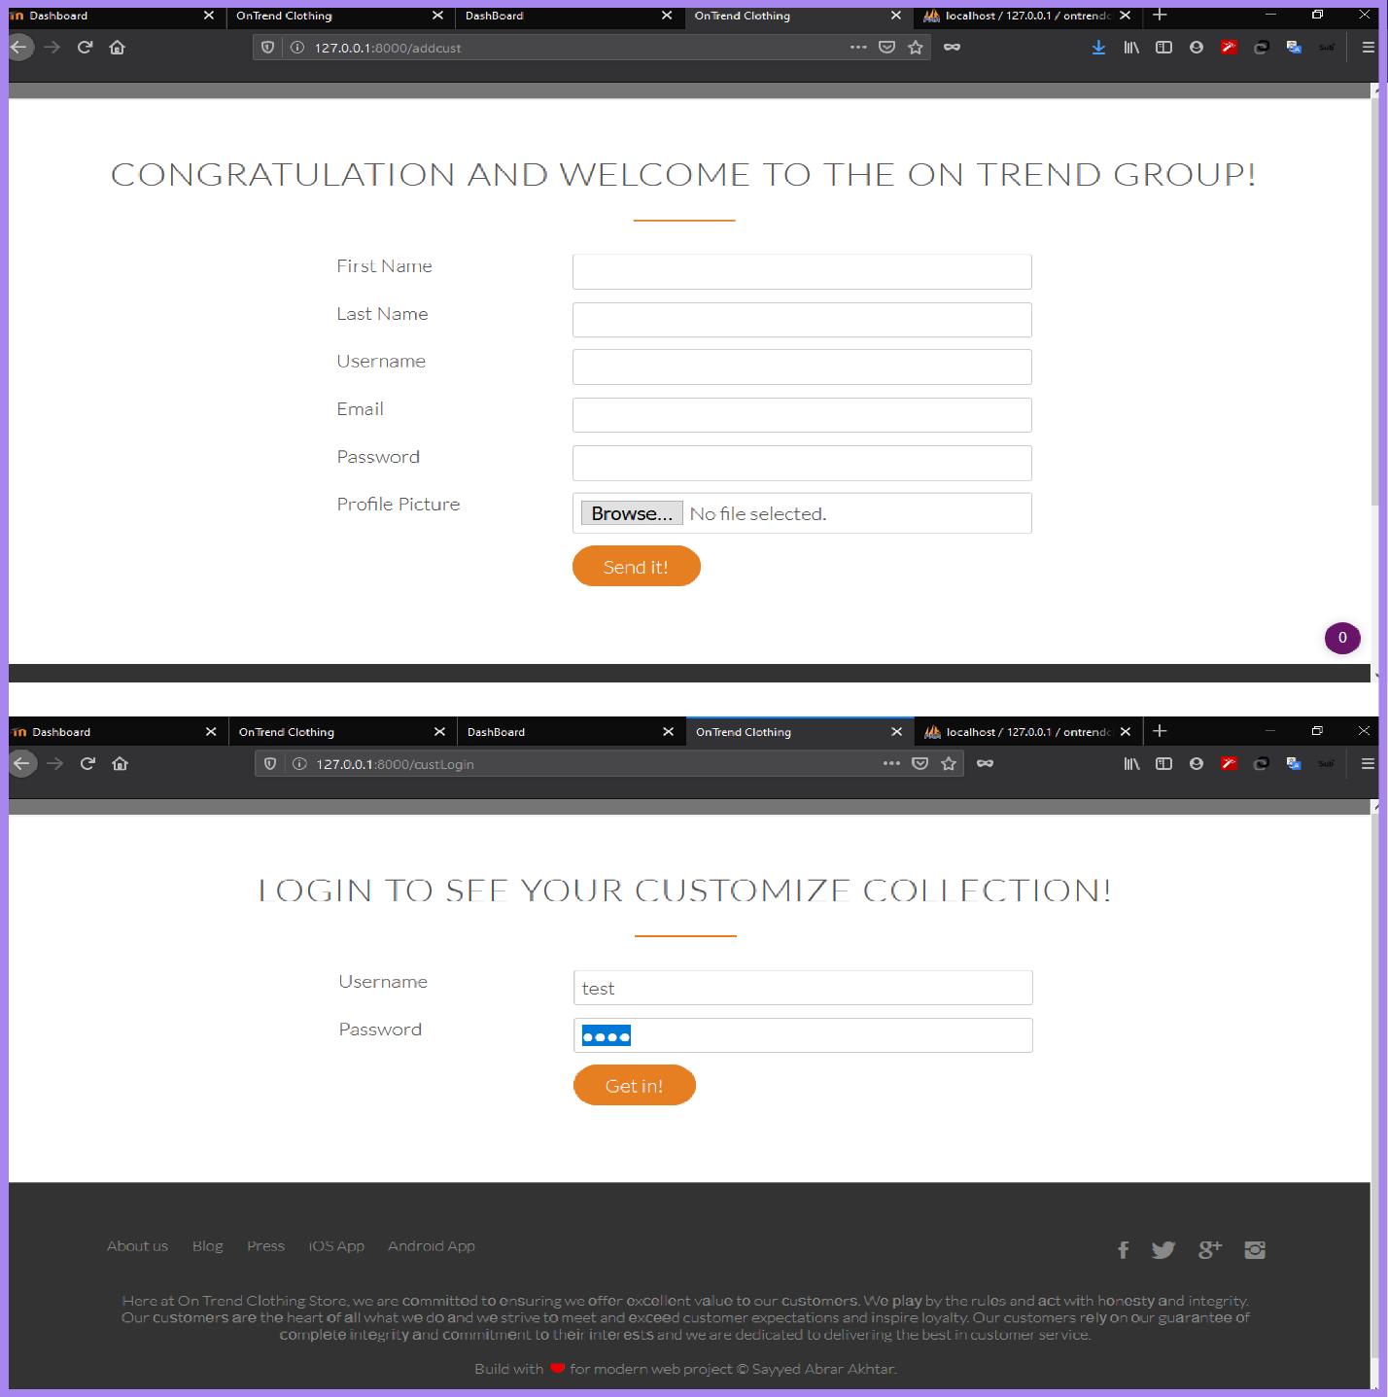

Figure 6: Customer signup and login page

Talking about the framework, I have used Bootstrap framework and normalize.css a CSS file for designing the website grid and make website responsive. Responsive website is a website that automatically resize, changes layouts on different size to make a website looks good and easily readable. (Mark Otto, 2020)

Before webpages were mostly surfed on the desktops and laptops. Now with the decrease of digital divide and with the introduction of android, people mostly use smartphones to open websites. The website designed for laptop and desktop are made for larger screen view. Such website if opened in a smartphone which has smaller screen can be unreadable and looks bad. To overcome these issues a website should be made responsive.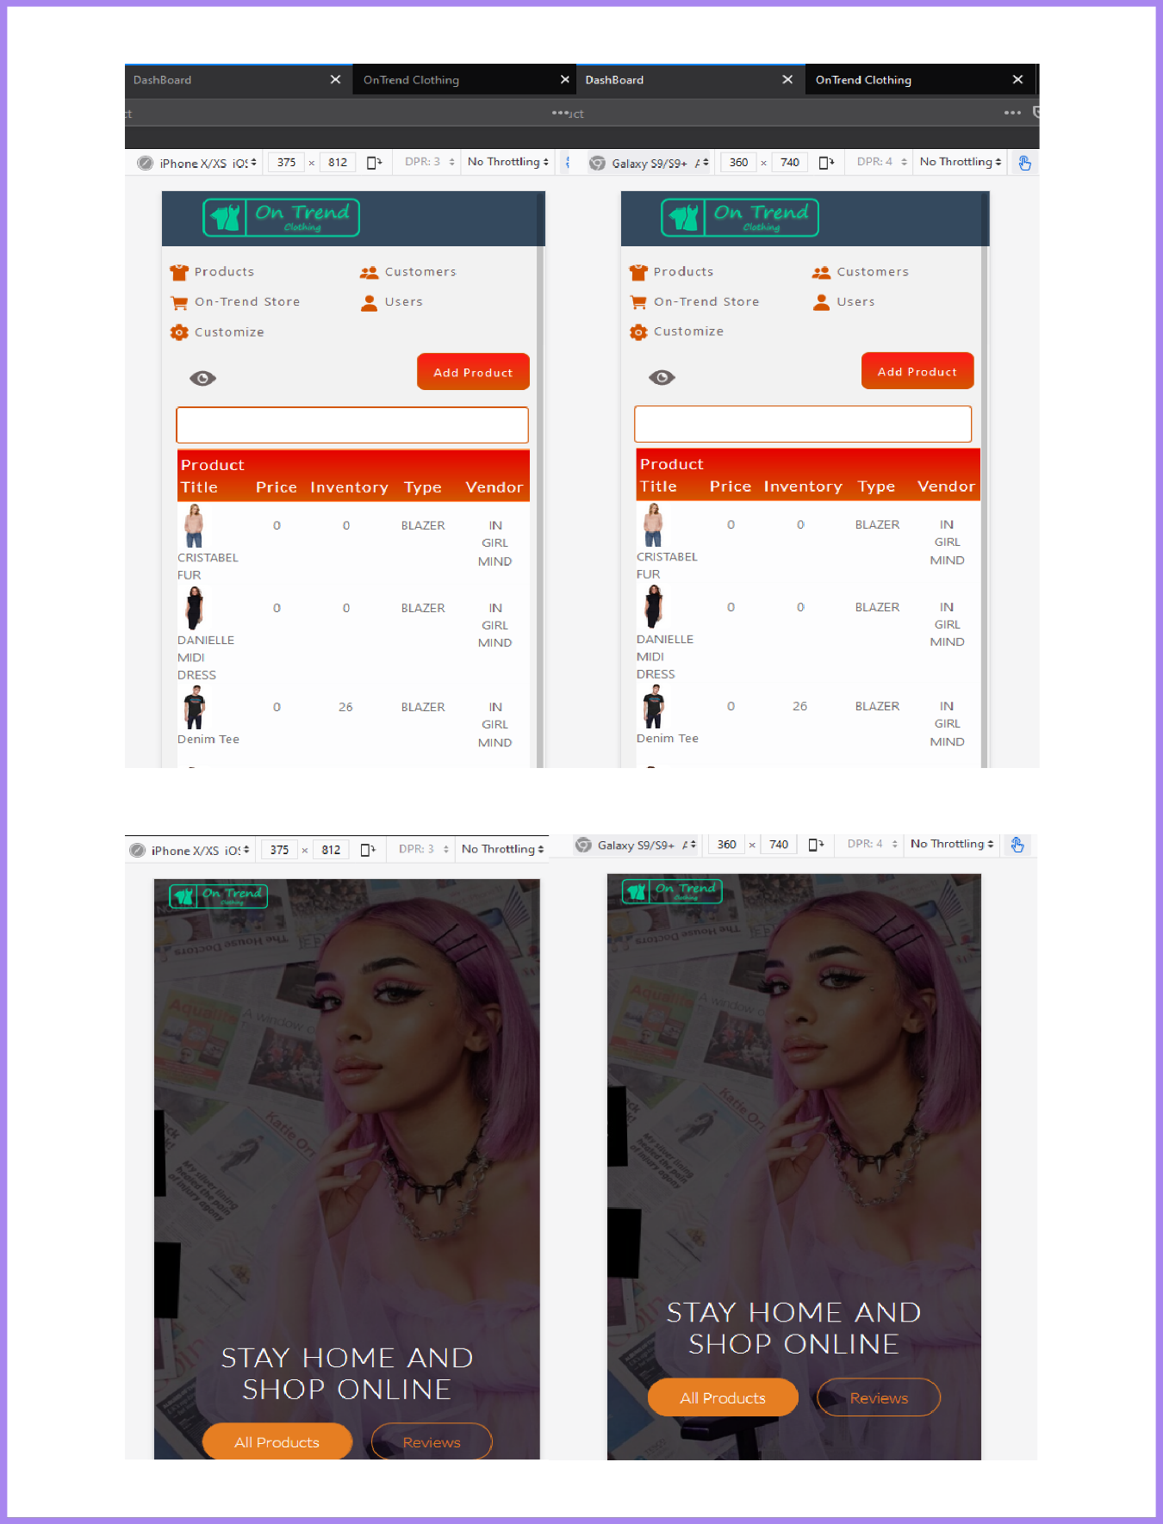

Figure 7: Responsive design

# Databases

Most of the website nowadays stores data and use such data for providing better service to the customer. Even more, website store their own data, Amazon.com, daraz.com, etc. are some online stores who store their products and customer data. In my website also I have products, customers, users and website data. To store such data, I have used MySQL open source database. MySQL is a leading database choice for storing website data.

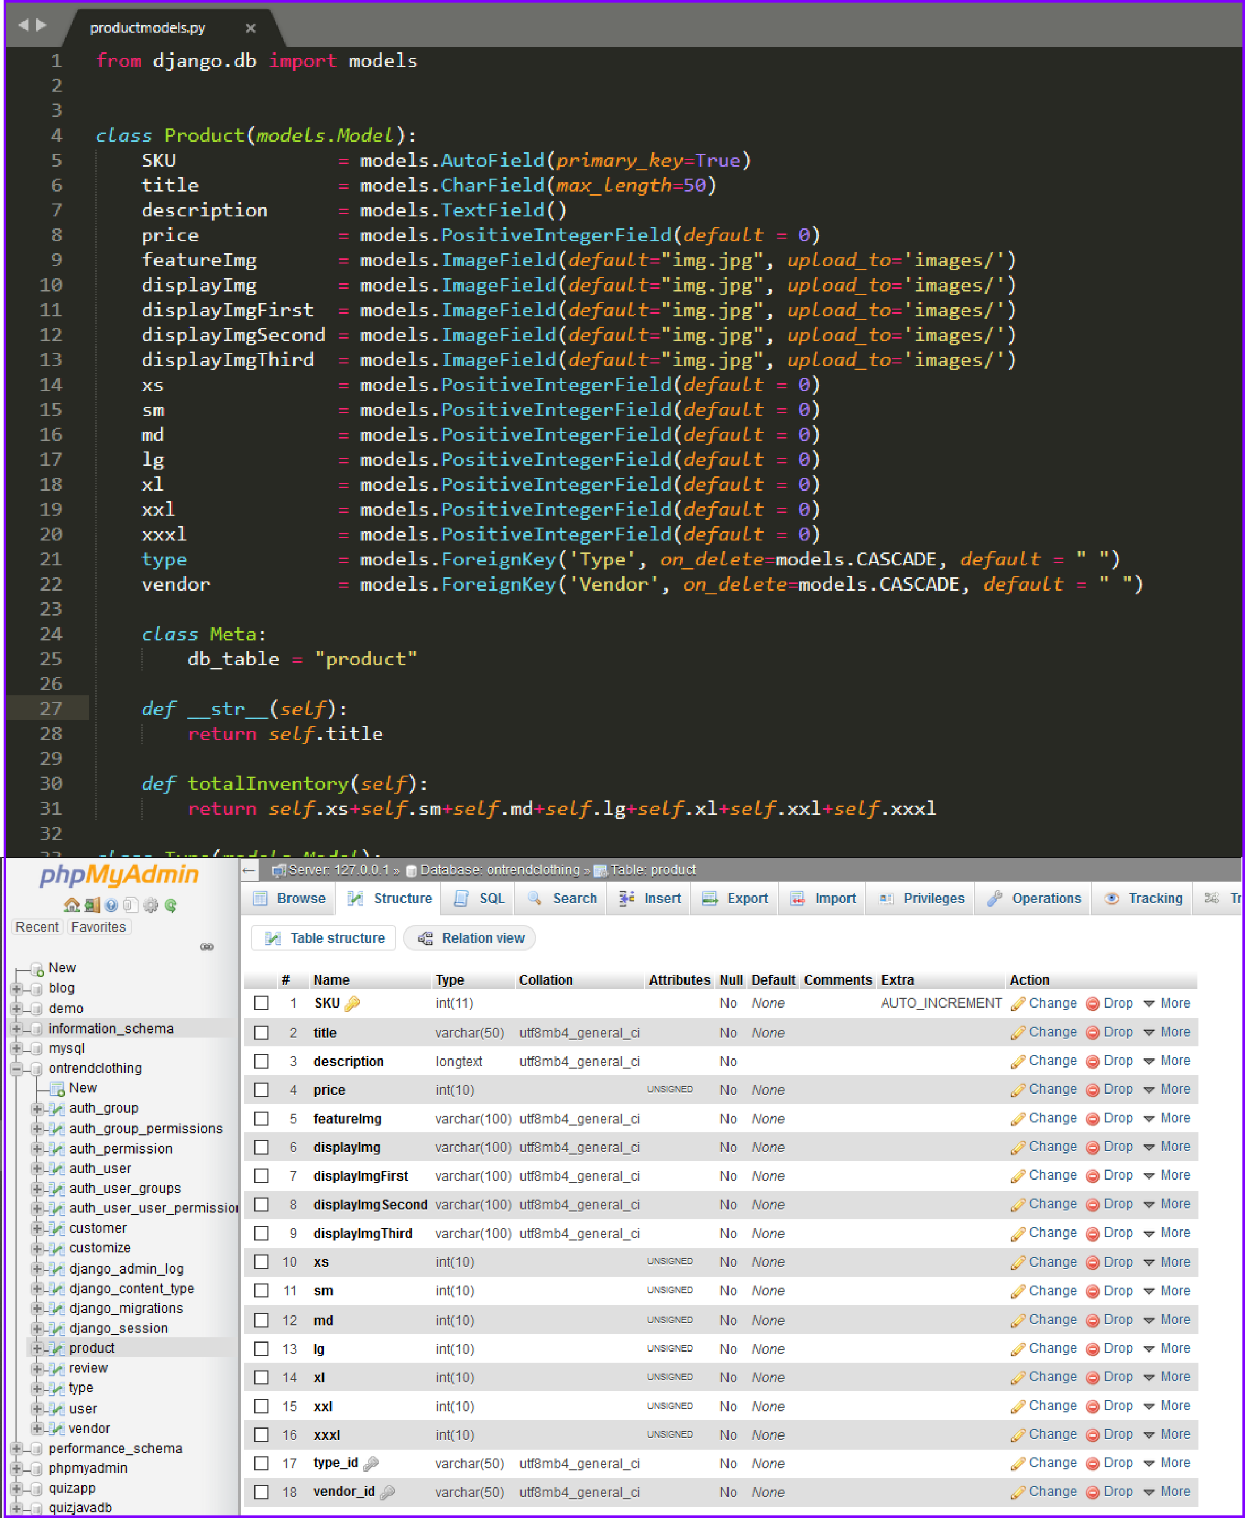

Figure 8: Product Table

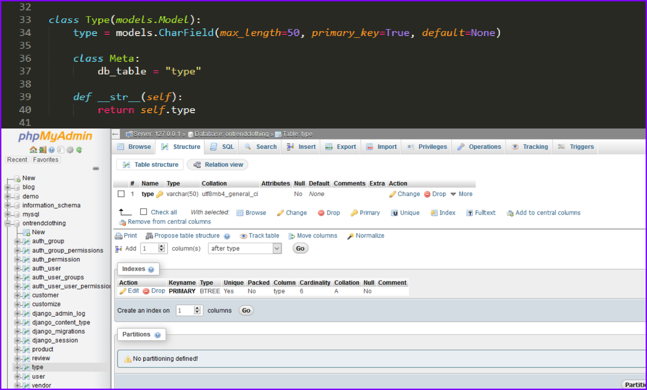

Figure 9: Type table

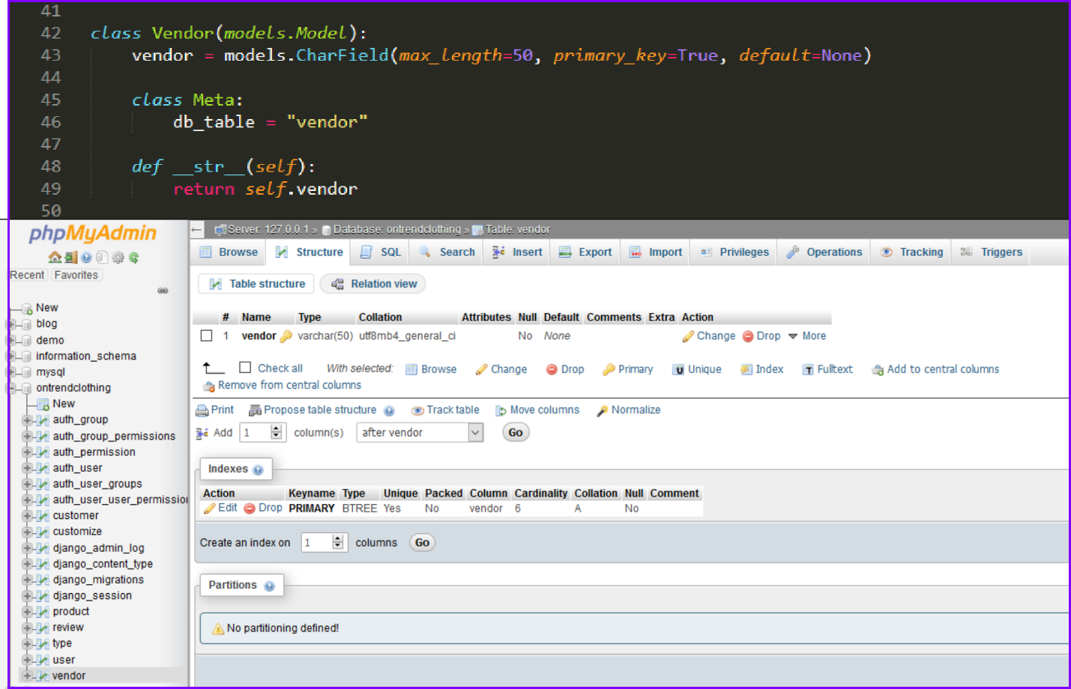

Figure 10: Vendor table

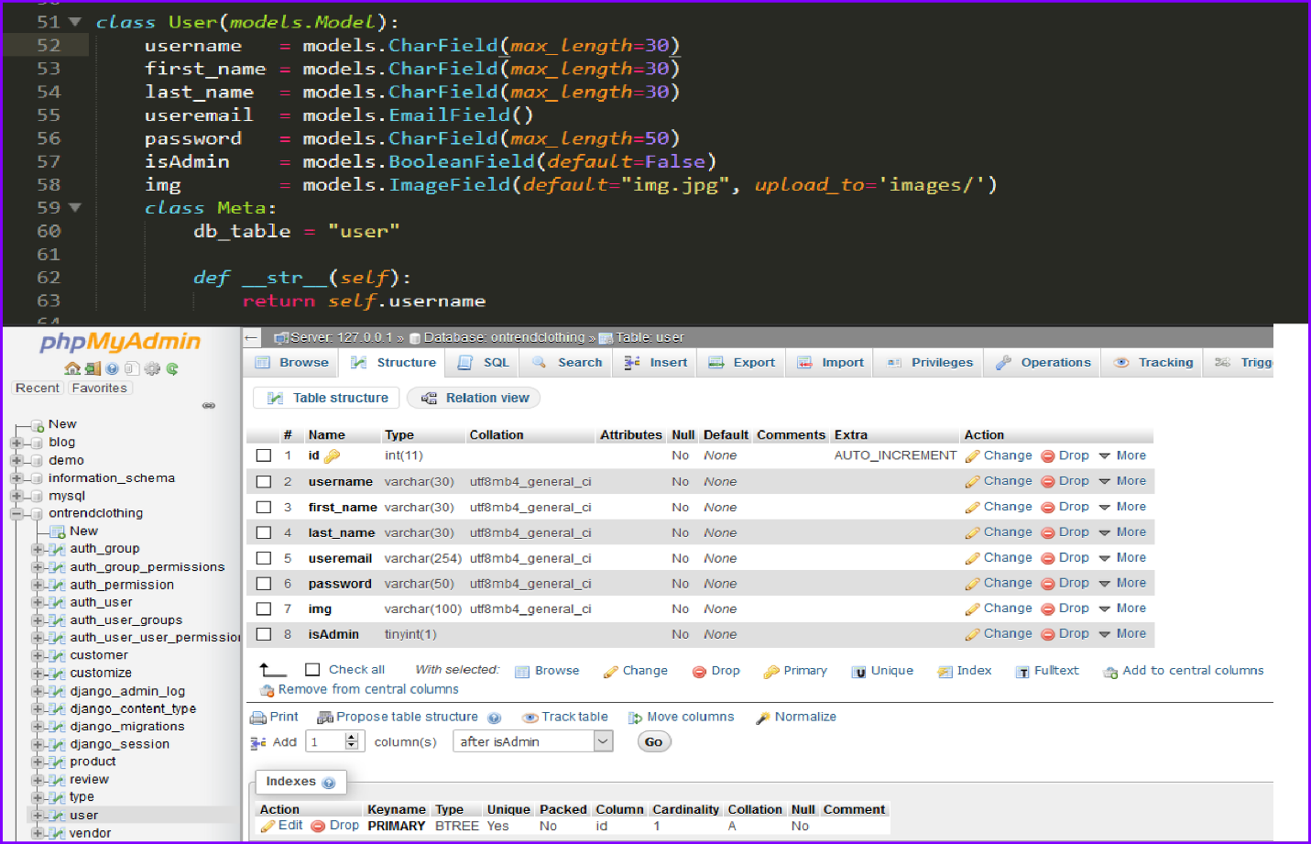

Figure 11: User table

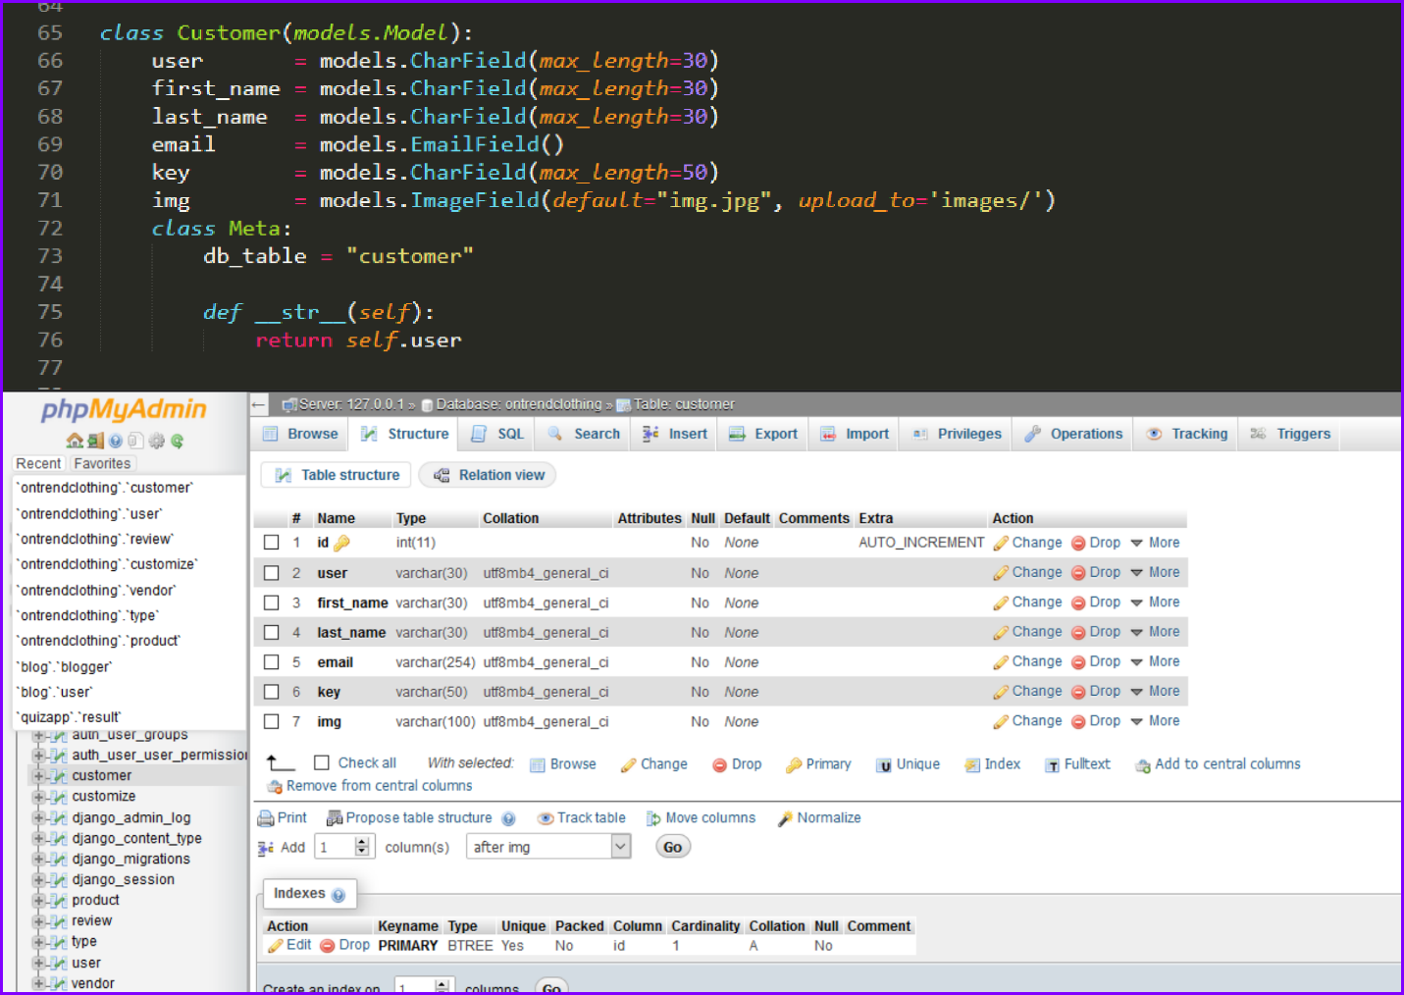

Figure 12: Customer table

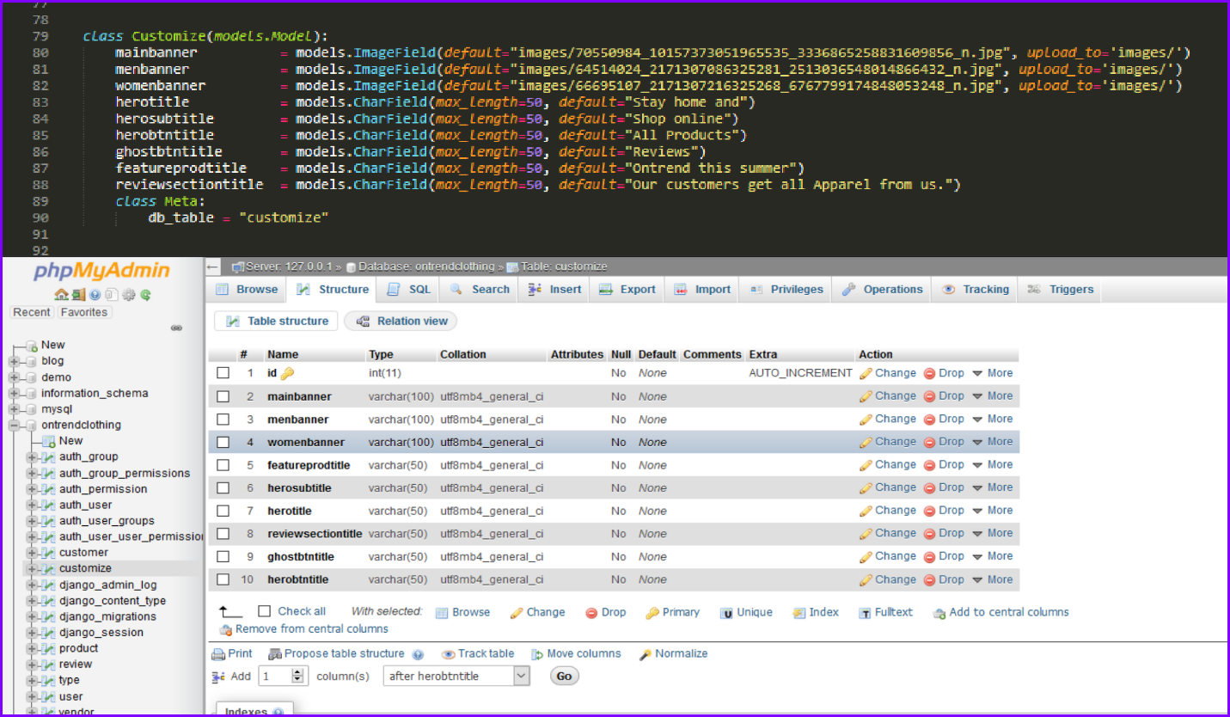

Figure 13: Customize table

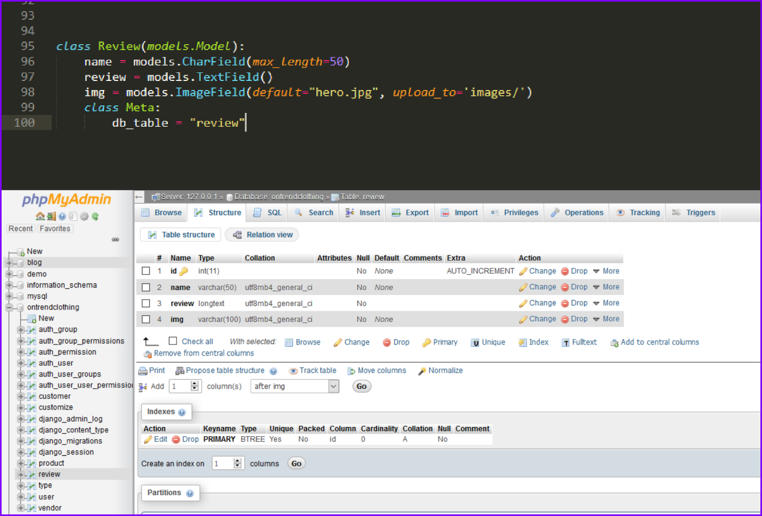

Figure 14: Review table

Advantages of MySQL database are:

* It is easy to use
* It is an open source database
* It is popular and has industry standard

Challenges of MySQL database are:

* It has some stability issues
* It has poor performance scaling; we cannot use it with high concurrency level of operations.
* The database has limitation in areas like fault tolerance, warehousing, and so on

(Mysql.com, 2020)

# Backends

Backend is a part of website that sends and retrieves data to and from frontend. More than it handles backend and frontend operations. It ensures that frontend works. It communicates with frontend for transmission of information. Such information is displayed as webpage. Together backend and frontend make a website dynamic. Content on the website are stored on database and can be dynamically changed. This differentiate it from static website whose content stays the same.

For backend development I have used Django, a high-level Python web framework. It is an open source. Development is fast, secure and scalable in Django. Models, views and template design pattern is used in developing the backend. Models create database table; views contain the table’s data operation and template contains the html files to render and request such data to the webpage. (Djangoproject.com, 2020)

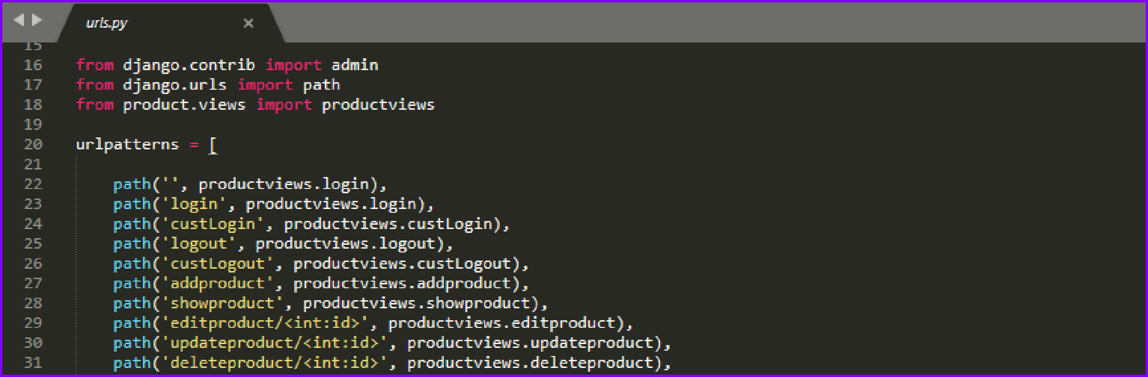

Figure 15: URLs

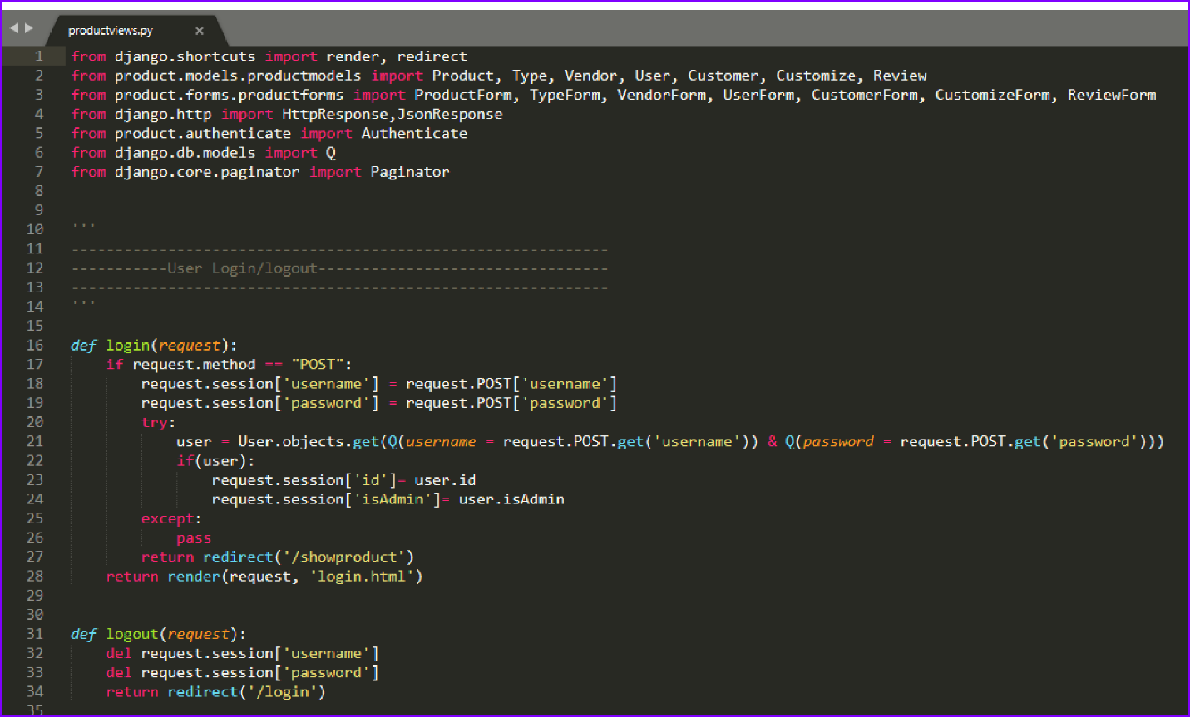

Figure 16: Django views operation

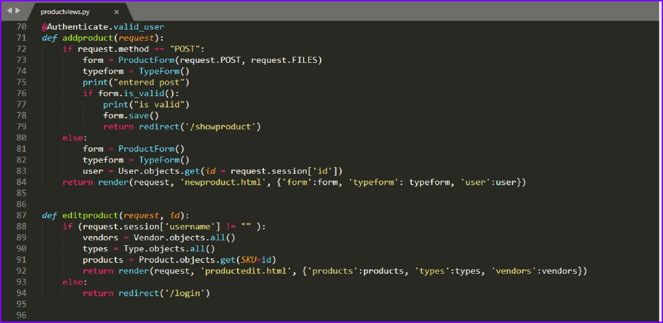

Figure 17: Django views operation 1

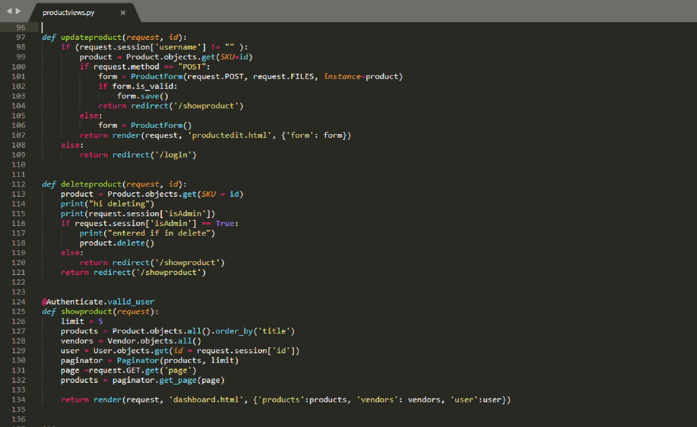

Figure 18: Django views operation 2

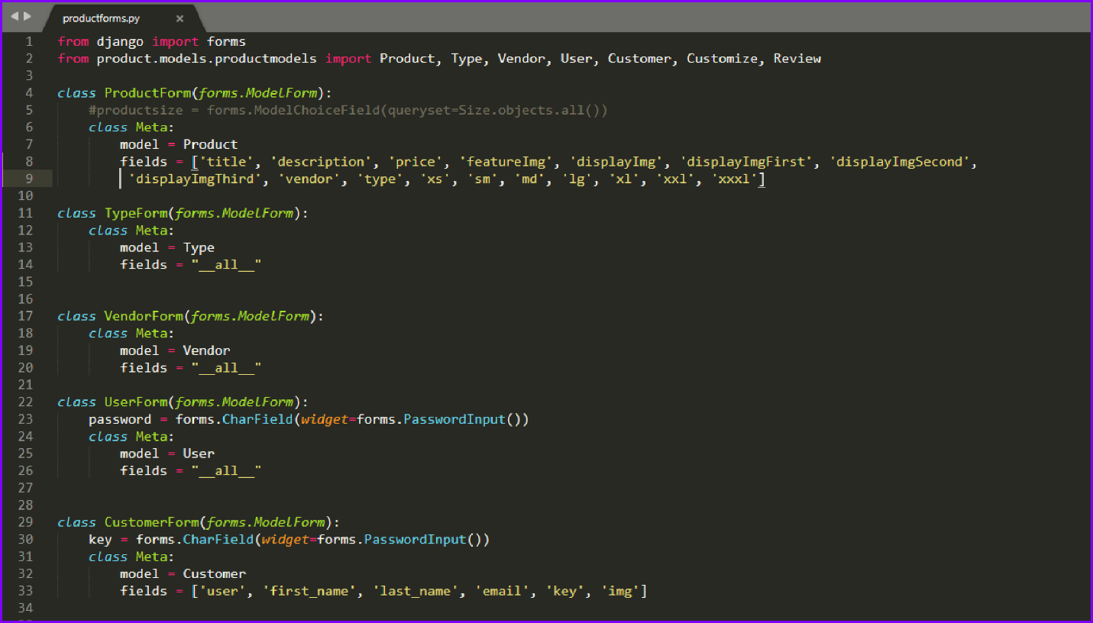

Figure 19: Django forms

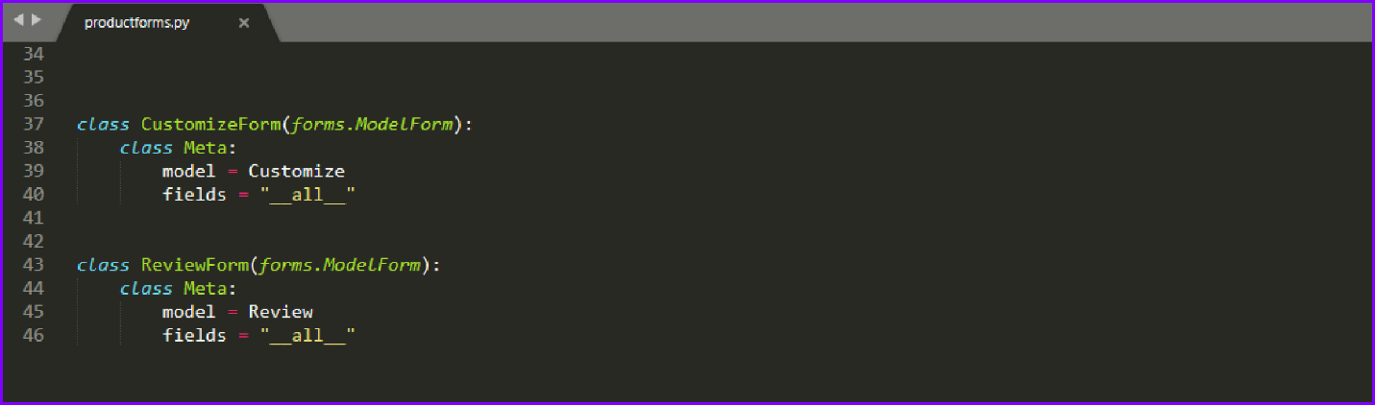

Figure 20: Django forms 1

The website idea is not unique but to apply those ideas was difficult. To fetch data from foreign table was one of the issues generated during the development, which has taken lots of development time. Moreover, dealing with URL paths, sending various data from database to webpages was challenging.

The website has certain limitations. Website with huge amount of data started to hang. It does not offer cart option. My future works includes removing these limitations, developing a website that calculate the land area and based on certain facts provides an estimate to build a house or building as per customer requirements.

# Conclusion

Thus, a full stack website is developed using HTML5, CSS3, JavaScript and its library, Django web framework and Bootstrap to make responsive webpage. During the development lots of issues were generated but with patience I had continued project solving those issue with the help of our lecturer and guide Mr. Hari sir.

# References

1. W3schools.com. (2020). *W3Schools Online Web Tutorials*. [online] Available at: https://www.w3schools.com/ [Accessed 10 Jan. 2020].
2. W3schools.com. (2020). *HTML Tutorial*. [online] Available at: https://www.w3schools.com/html/default.asp [Accessed 14 Jan. 2020].
3. W3schools.com. (2020). *JavaScript Tutorial*. [online] Available at: https://www.w3schools.com/js/default.asp [Accessed 20 Jan. 2020].
4. Mark Otto, a. (2020). *Introduction*. [online] Getbootstrap.com. Available at: https://getbootstrap.com/docs/4.4/getting-started/introduction/ [Accessed 25 Jan. 2020].
5. Mysql.com. (2020). *MySQL*. [online] Available at: https://www.mysql.com/ [Accessed 02 Feb. 2020].
6. Djangoproject.com. (2020). *The Web framework for perfectionists with deadlines | Django*. [online] Available at: https://www.djangoproject.com/ [Accessed 02 Feb. 2020].